
Issue 28 April 2016
www.cardiff-sands.co.uk

Welcome
We hope that this newsletter will provide you information on who we are, what we do and what we are up to. If you have any ideas, news, articles etc that you would like us to place in the newsletter please e-mail Claire at
cardiffsands_newsletter@hotmail.co.uk

The newsletter is issued every four months so the next issue will be in December, if you do have any news, articles, fundraising events, stories or poems that you would like to be added please e-mail the above address before November 16th. Previous issues of the newsletter can be found on www.cardiff-sands.co.uk
Who are we?
Cardiff & Newport Sands support group is for anyone who has been affected by the loss of a baby, be that late miscarriage, termination for an abnormality, stillbirth or neonatal loss.
We hold a monthly support meeting at St.David’s Hospital,
Cowbridge Road East, Canton, Cardiff, CF11 9XB. They are held on the last Thursday of every month, 7-9pm. Free parking is available.
The meetings are very informal, you can say as much or as little as you want. It is basically for people to share their experiences and feelings with others who have gone through similar and understand.
For more information go to www.cardiff-sands.co.uk

We also now run a next pregnancy support group, 7.15-915pm,on the last Thurs of the month at St.David’s Hospital, Canton, Cardiff

We have a befriender phone number in case anyone just needs someone to talk to. For the befriender number please call Sands on
020 74367940, or e-mail head office at support@uk-sands.org

Dates for the Diary

Sunday 2nd October
Cardiff Half Marathon.
If you are running for Sands in the Cardiff Half Marathon please ensure you have registered via Sands Fundraising. They will send you a fundraising pack and from there you can order a Sands running vest. https://www.uk-sands.org/get-involved/fundraising-ideas/register-your-event
We are hoping to get a team photo pre race, more details nearer the time so keep an eye on our facebook page or your emails. If you aren’t running we are going to have a cheering point somewhere along the route, again keep an eye out on our social media/emails for details about this.
9th – 15th October
International Babyloss awareness week ending in the wave of light on the 15th October at 7pm where you light a candle in memory of your baby. Keep an eye on social media about all the events happening that week across the UK and in fact the world.
Friday 14th October
October 2016 marks our 10th birthday and to celebrate this, and to coincide with Babyloss Awareness Week we are holding a charity ball at the Copthorne Hotel, Cardiff. Tickets will be £35 each or £300 for a table of 10 (see poster on next page)
Lights of Love
This year it will be held on the 9th December, location to be announced.

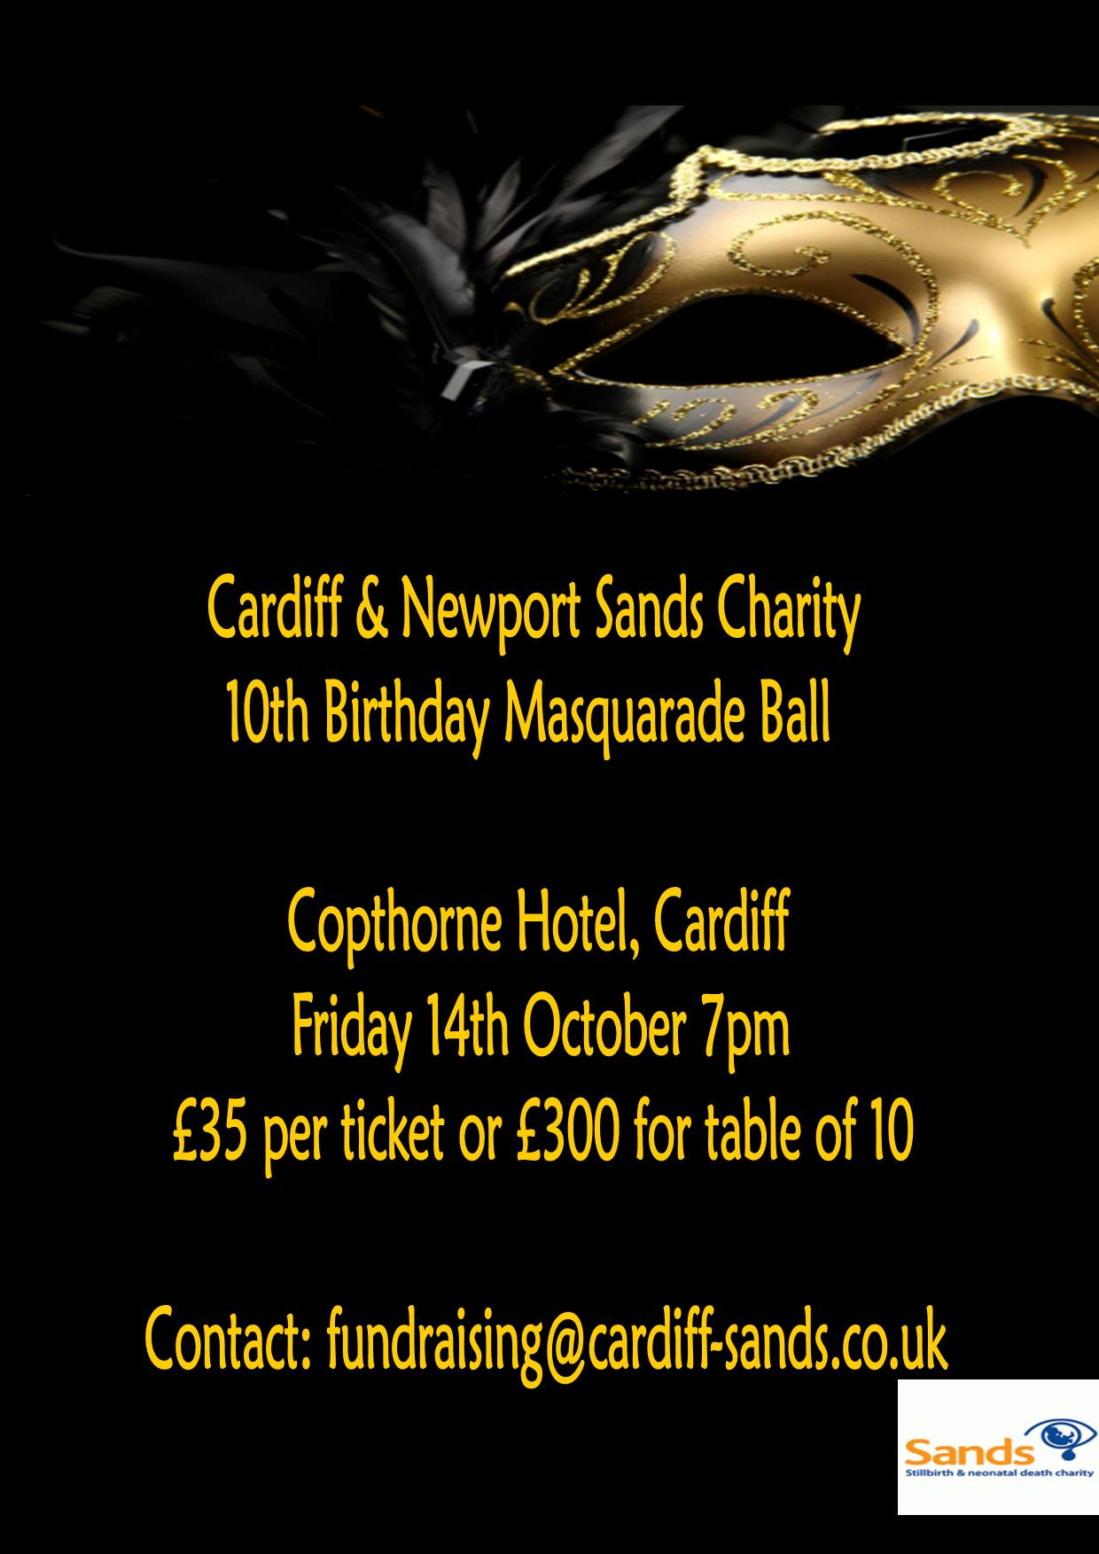

Raffle Tickets & Auction Items

Raffle tickets for the ball are available to purchase if you cannot make the event, you can pay via www.justgiving.com/sandscharityball
They are £1 a ticket and come in books of 5. If you are purchasing online don’t forget to send in your contact details which will be written on the ticket for you (you can message on our facebook page or email fundraising@cardiff-sands.co.uk)
Auction items will be available to bid on nearer the time, and the highest bid will then be taken onto the ball where a proxy bidder will bid in your place. Once all the items have been received we will let you know what is up for auction.


Congratulations to our lovely befriender Pip Gwyn who married Andrew Sweeney in July and also to Gemma Self who passed her befriender training and is now a befriender for us. Also huge congratulations to all those who have had their Rainbow Babies recently, remember our lovely Pip runs a Rainbow Babies Group in Café Junior, 2nd Friday of every month 10am – 12pm.



Befriender Walks A Mile In Someone Else’s Shoes

June saw Cardiff & Newport Sands in partnership with Bereavement Services hold their annual joint Remembrance Service at the end of June. The group decided that they would follow up the service by hosting their Walk a Mile and also a Teddy Bears Picnic in Morgan Jones Park, Caerphilly.

Although numbers were good, unfortunately the weather was not. Before the walk the Ugly Shoes Poem was read by Chair of the Group Hj and then our lovely treasurer Claire and husband Gwyn led the group on their walk. Befriender Dave Coombs wore secretary of the group Caroline Allsopp’s shoes and really did walk a mile in her shoes. After the walk some decided to carry on their picnics under umbrella’s whilst others held with tradition and ate in the car!

Photo shows some of the wonderful t-shirts being worn by mums at the event.

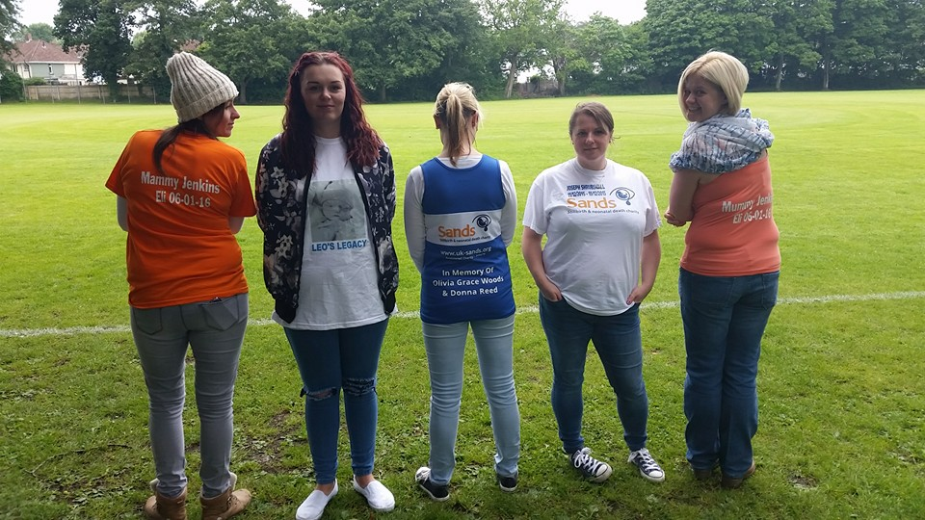

Holiday Money

Thanks to our Treasurer Claire we were given the opportunity to hold a bucket collection on the 7th August at Cardiff Airport. 16 volunteers over a period of 8hrs held their lovely orange sands buckets for travellers to lighten their loads before they jetted off on their adventures. The amount raised was £208.21, 9.82 Euros and 1 dime!! I would like to say a huge thank you to those who volunteered as it can be a very long 2 hours stood with our buckets and without as many people coming forward we would not have been able to cover from 9-5pm. To be given the opportunity at these events is so important to us, as not only do we raise funds we also raise awareness. Thank you again to those who gave up 2hrs of their Sunday xxx

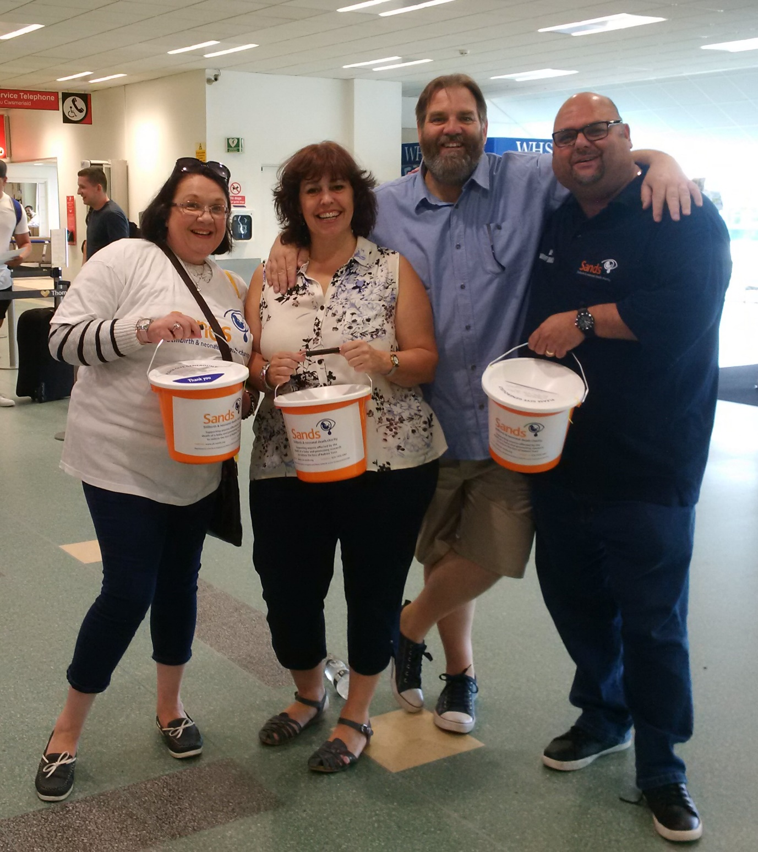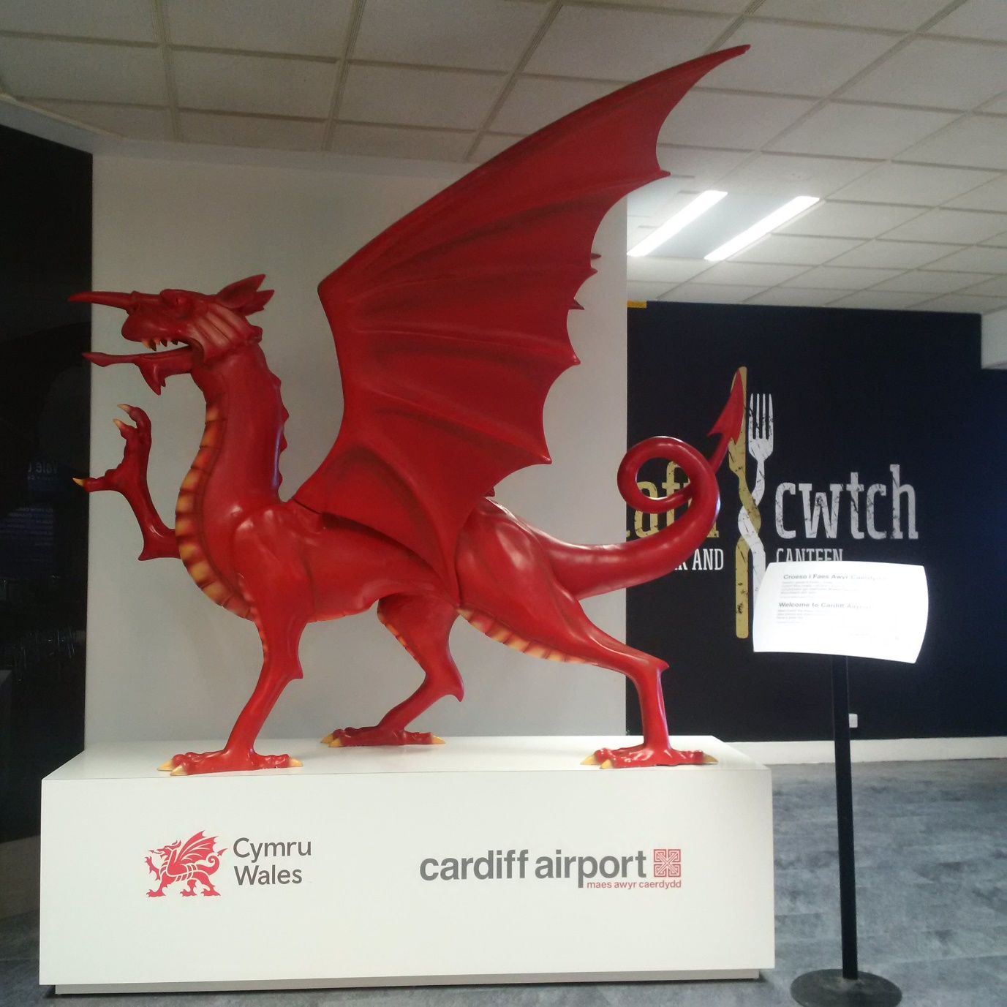

Leo's legacy fundraising day
On 30th July I had a fundraising day to raise money in aid of sands to raise money for a new bed for the Bereavement suite in Heath hospital. The community came together, and many other people from other communities to make the day happen. We had a dj, dancers, ice cream van, bouncy castles, gladiator podium, candy floss and popcorn cart, face painter, stalls, raffle,and a charity baseball game. We also had a signed Cardiff Blues shirt that was auctioned off. We managed to raise a fantastic £753.80 to go towards the new bed. I wanted to do something for other parents as I know how heartbreaking it is to lose a baby so I wanted to do something in memory of Leo. That's when I thought of doing a fundraising day which I called Leo's legacy. My story was covered by itv news and Wales online and reached as far as America, and Leo's legacy also has its own Facebook page which reached 4000 members! I want to thank everyone who helped me and made this happen and also came to Leo's fundraising day.
Laura Williams

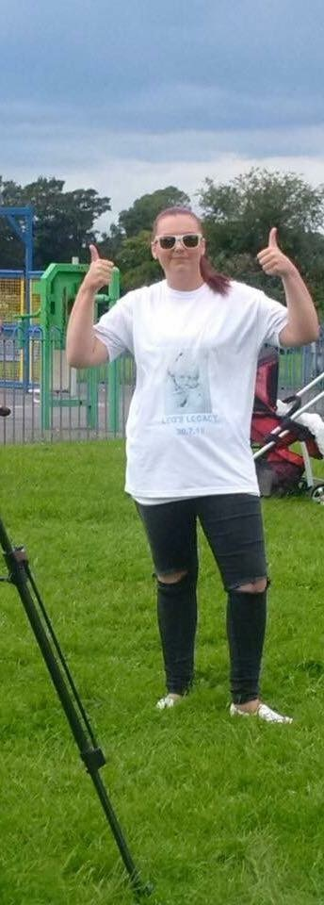

Thank You
To everyone who raises money or donates to us, without you we cannot provide the support we do to parents, families and professionals.

As examples of what we use the money for, in 2015 we have paid for midwives from four local hospitals to attend the Sands/Bliss Conference in London, Cuddle cots for UHW and Sands Befriender training. As well as this we continue to supply four local hospitals with memory boxes, hand and ink kits, hand and footprint memory booklets and Sands support packs. We also pay for the printing of leaflets that are given out in the Cardiff & Vale UHB hospitals regarding pregnancy loss at any stage and what choices are regarding funerals.



A PAIR OF SHOES

I am wearing a pair of shoes,
they are ugly shoes
uncomfortable shoes
I hate my shoes.
Each day I wear them, and each day I wish I had another pair.
Some days my shoes hurt so bad that I do not think I can take another step, yet I continue to wear them.
I get funny looks wearing these shoes.
They are looks of sympathy.
I can tell in others eyes that they are glad they are my shoes and not theirs.
They never talk about my shoes.
To learn how awful my shoes are might make them uncomfortable.
To truly understand these shoes you must walk in them,
but once you put them on you can never take them off.
I now realise that I am not the only one who wears these shoes.
There are many pairs in this world.
Some women are like me and ache daily as they try and walk in them.
Some have learned how to walk in them so they don't hurt quite as much.
Some have worn the shoes so long that days will go by before they think about how much they hurt.
No woman deserves to wear these shoes.
Yet, because of these shoes I am a stronger woman.
These shoes have given me the strength to face anything.
They have made me who I am.
I will forever walk in the shoes of a woman who has lost a child.

Author: unknown

We Remember
August – November

August
5th Aug 2012 Finlay William Chapell
14th Aug 2009 Charley McFall
22nd Aug 2008 Seren Morgan Davies
22nd Aug 2011 Morgan Self
27th Aug2010 Esme Rose Thomas-Faux
29th Aug 2007 – 30th Aug 2007 Ava Rose James

September
1st Sept 2011 Callum Gareth Morris
3rd Sept 2004 Xander Dangerfield Coombs
3rd Sept 2009 Freddie Cornelius
6th Sept 1995 Deborah Anne Ratcliffe
6th Sept 2003 Lucia Rose Kilshaw
17th Sept 2006 Grace Madison Bird
20th Sept 2006 Alex Christine Lambert
21st Sept 2006 William Sutherley
24th Sept 2013 Sienna Rose Evans
27th Sept 2006 Katy Jones
28th Sept 1998 Evan Lippiatt

October
9th Oct 1997 Bethan Victoria Cook
10th Oct 2007 Iestyn Hewings
14th Oct 2015 Phoebe Betty Knowles
18th Oct – 24th Oct 2006 Molly Frances Jones
18th Oct 2003 Adam Lippiatt
1 9th Oct 2009 Miley Jayne Ayres
26th Oct 2002 Megan Smyth
28th Oct – 31st Oct 2011 Harry George Williams
31st Oct 2010 Cole Raymond Gallagher-Huntley

November
5th Nov 2005 Seren Roberts
8th Nov 2008 Lucy Annabelle Ingram
8th Nov 2008 Kai Patrick Lewis Crowley
8th Nov 2014 Elsie Grace Machin
22nd Nov 2013 Melody Eleanor Griffiths
27th Nov 2008 Lewys Christopher Bailey
28th Nov 2013 Ophelia Olwen Wright-Davies

If you would like your babies name adding to our We Remember section please email their full name and date of birth (and date of death if different) to cardiffsands_newsletter@hotmail.co.uk
Contacting National Sands
SANDS NATIONAL HELPLINE: 020 7436 5881

Mon-Fri 9.30am-5.30pm
Tues & Thurs eve 6pm-10pm
Closed weekends

The Helpline team are there to listen and give support. They can advise you about finding local help, whether from a SANDS group or other counselling services, and have information about other relevant support organisations.
SANDS HEAD OFFICE: 020 7436 7940
The Office is open 10am – 5pm, Monday - Friday
The office admin line is there for a broad range of enquiries relating to stillbirth and neonatal deaths.

WRITE TO:

Victoria Charity Centre
11 Belgrave Road
London
SW1V 1RB

E-MAIL:
For the helpline support mail: helpline@uk-sands.org
For all general enquiries mail: support@uk-sands.org
For fundraising issues mail: fundraising@uk-sands.org

SEND A FAX:
020 7436 3715
WEB SITE:
http://www.uk-sands.org/

