
Issue 30 Dec 2016
www.cardiff-sands.co.uk

Welcome
We hope that this newsletter will provide you information on who we are, what we do and what we are up to. If you have any ideas, news, articles etc that you would like us to place in the newsletter please e-mail Claire at
cardiffsands_newsletter@hotmail.co.uk

The newsletter is issued every four months so the next issue will be in December, if you do have any news, articles, fundraising events, stories or poems that you would like to be added please e-mail the above address before November 16th. Previous issues of the newsletter can be found on www.cardiff-sands.co.uk
Who are we?
Cardiff & Newport Sands support group is for anyone who has been affected by the loss of a baby, be that late miscarriage, termination for an abnormality, stillbirth or neonatal loss.
We hold a monthly support meeting at St.David’s Hospital,
Cowbridge Road East, Canton, Cardiff, CF11 9XB. They are held on the last Thursday of every month, 7-9pm. Free parking is available.
The meetings are very informal, you can say as much or as little as you want. It is basically for people to share their experiences and feelings with others who have gone through similar and understand.
For more information go to www.cardiff-sands.co.uk

We also now run a next pregnancy support group, 7.15-915pm,on the last Thurs of the month at St.David’s Hospital, Canton, Cardiff

We have a befriender phone number in case anyone just needs someone to talk to. For the befriender number please call Sands on
020 74367940, or e-mail head office at support@uk-sands.org

Dates for the Diary
Friday 12th May
Darts
TBC – keep an eye out on social media/e-mail regarding this event. Final details are still being organised
Saturday 24th June
Pen Y Fan Climb
Our Chair HJ is organising a Welsh Network Pen Y Fan climb. All welcome, just need to email HJ on heatherjane.coombs@uk-sands.org so she can add you to the team. We will be raising money towards a special Welsh Sands Garden which we are looking at developing in Powys (central to all in Wales). We will be taking up bunting with babies names on so if you can’t join us but would like your babies name added to the bunting you can sponsor a bunting triangle up until the middle of June (15th). Details of the Just Giving page so that you can do this will be announced shortly.
Sunday 25th June
Thornhill Baby Remembrance Service
This is an annual remembrance service organised by ourselves with Cardiff Council Bereavement Services. More details nearer the time
Friday 30th June
Annual Golf Tournament
After a year’s absence last year due to our organiser Gwyn Roberts spending 2 weeks in France following Wales in Euro 2016, this annual event is back. This year it is being held at Llanishen Golf Club, Cardiff. See poster on next page or for more details email golf@cardiff-sands.co.uk. Photos and details of the previous golf events can be found on our website

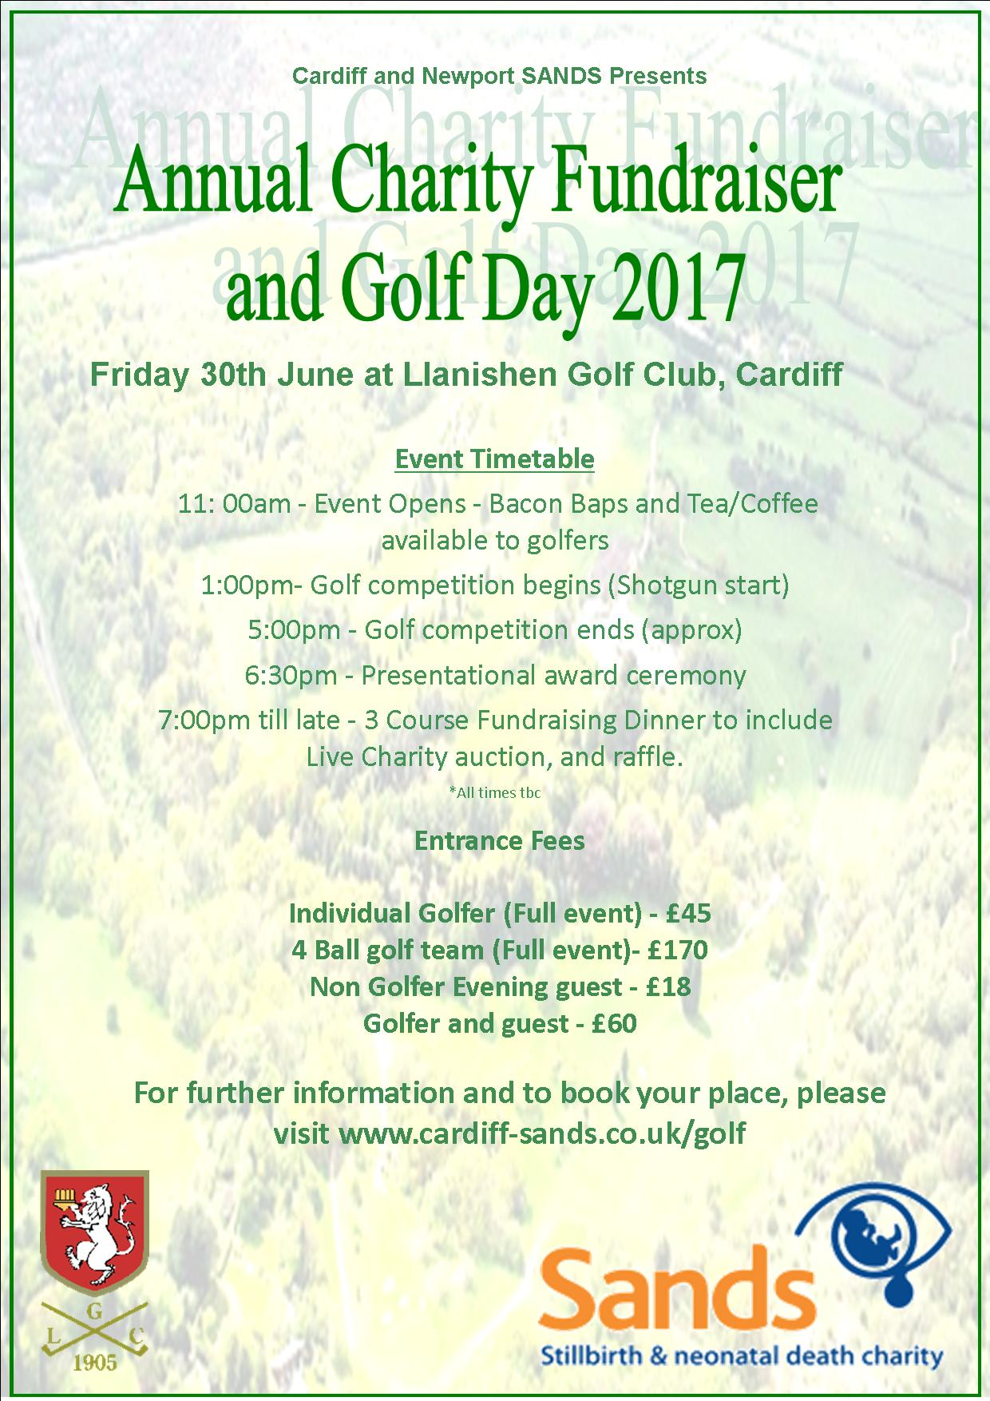

Cardiff & Newport Sands 10th Anniversary Masquerade Ball, Copthorne Hotel, Cardiff

We celebrated our 10th Anniversary of supporting parents in October and held a Masquerade Ball.
The event was well attended by over 100 people. Also there was magician (Jamie DeNiro Williams), photographer (Clare Price) and a photo booth (Roger Gale and M4 Photobooths) who all donated their time and resources to entertain everyone and raise a bit of money. So a big thanks to them.
An auction and raffle were held after a 3 course meal and over £2,200 was raised whilst everyone had a wonderful time. Our auctioneer compare Gwyn Roberts and his amazing assistant Claire Roberts, did a fabulous job in getting the bidding going in an upwards direction!
Unfortunately even after months of stalking from Hj, Gary Barlow did not attend, but Michael Sheen did send a signed top for the auction, so stalking via twitter does work sometimes! He also retweeted photos of us auctioning his shirt.
HJ presented Caroline and Claire with long standing service medals for putting up with her for 10yrs and a bottle of wine, to help them to cope for the next 10yrs! HJ put together a presentation of pictures to the music “They Live In You” from the musical version of the Lion King, showing some high lights of the past 10yrs. This will be available to watch shortly on our website.
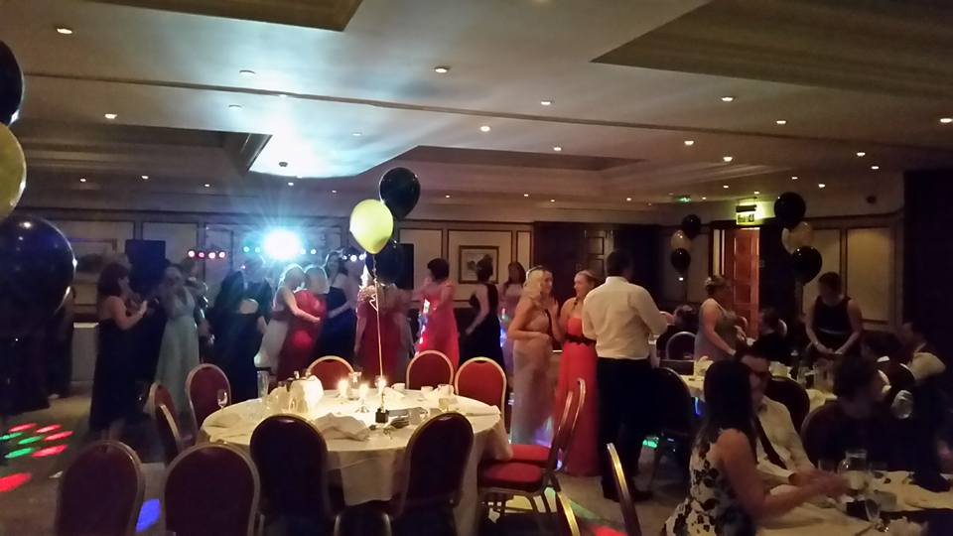
Wave of Light
In my capacity of Welsh Network Co Coordinator I made it my mission to try and get some big buildings in Wales, and hopefully some Castle’s to turn pink and blue on the 15th October at 7pm to support the Wave of Light and Babyloss Awareness Week.
I had some very interesting conversations including with the rugby clubs, as was hoping any games that were played on that day would give a mention to the date. One man took up the mantle though and helped me to arrange Cardiff City Hall turning Pink and Blue. Thank you so much to Jeff Cook at Cardiff City Hall for seeing my dream and making it reality. The building looked beautiful and have to admit as I stood in front of it taking photos, I cried. Seeing the support and even just one building breaking taboo was wonderful.
Within hours Facebook and Twitter and then Wales Online were full of the photos and the story. This year Jeff has agreed to go one better and is turning the building pink and blue for the whole of Babyloss awareness week from the 9th – 15th. What a legend of a man, thank you so much to him. Meant so much to so many, but on a personal level I will forever be grateful that he answered my email.

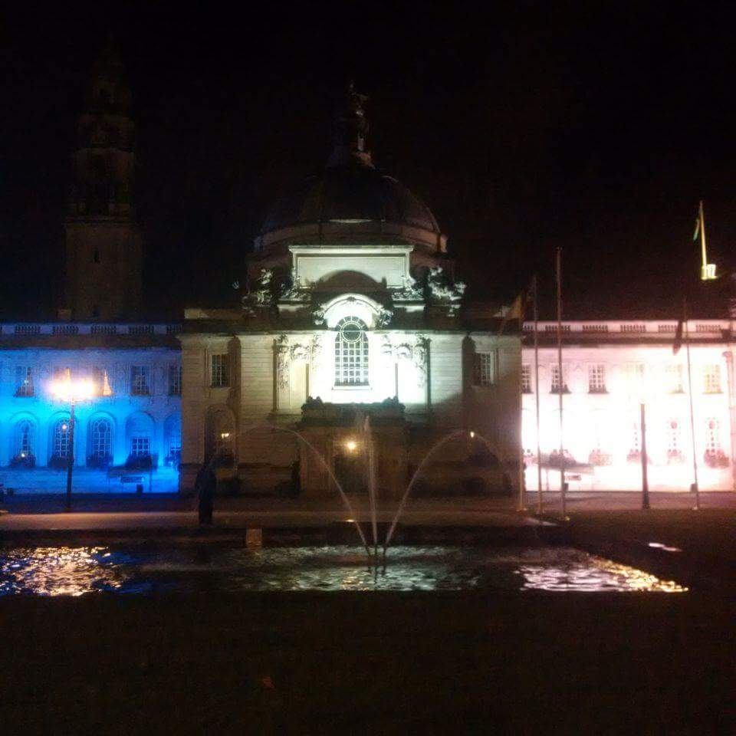
Special Brew
On the 15th October, Chair Hj was asked to attend an evening arranged by Special Brew and Sharon Bowles.
This was the 2nd year they had chosen to fundraise for Sands. The band started approx. 9pm with a crammed room of people enjoying the music. During the interval the raffle was held and thanks to Sharon for organising most of the prizes. After the band had been paid, just over £600 was raised. Thank you again for all the support.
Lights of Love
Lights of Love 2016 in Cardiff saw over 100 people attending the service. There were readings and poems, some that had been written specifically for the evening as well as Christmas songs and entertainment from Mello D.
Parents lit candles in remembrance, accompanied by Eleanor Evans on the harp. Parents were able to donate presents in memory of their babies, which were then taken to Cardiff City for the Big Wrap Charity. Thank you to everyone who gave up their time to help, to read, to sing, donate presents and all who donated to the raffle and lastly for attending and supporting each other. We couldn’t do these events without your support and the support of the people who give up their time. We also raised approx. £375 so thank you again x
Heatherjane Coombs
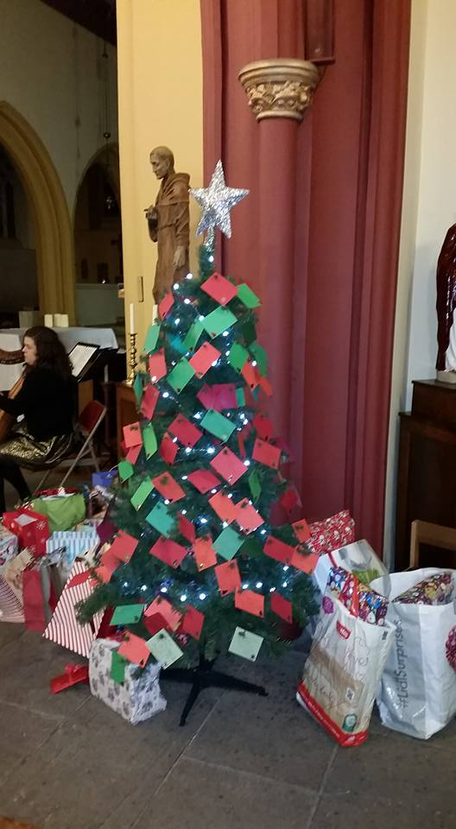

Little Snowdrop
The world may never notice
If a Snowdrop doesn't bloom,
Or even pause to wonder
If the petals fall too soon.
But every life that ever forms,
Or ever comes to be,
Touches the world in some small way
For all eternity.
The little one we long for
Was swiftly here and gone.
But the love that was then planted
Is a light that still shines on.
And though our arms are empty,
Our hearts know what to do.
Every beating of our hearts
Says that we love you.
Author Unknown

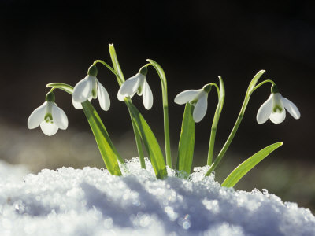

Thank You
To everyone who raises money or donates to us, without you we cannot provide the support we do to parents, families and professionals.

As examples of what we use the money for, in 2015 we have paid for midwives from four local hospitals to attend the Sands/Bliss Conference in London, Cuddle cots for UHW and Sands Befriender training. As well as this we continue to supply four local hospitals with memory boxes, hand and ink kits, hand and footprint memory booklets and Sands support packs. We also pay for the printing of leaflets that are given out in the Cardiff & Vale UHB hospitals regarding pregnancy loss at any stage and what choices are regarding funerals.



We Remember
December – March

December

3rd December 2009 Maisey and Oliver Rees
6th December 2009 Ethan Rhys Bignell
12th December 2012 Felicity Crocker
17th December 1998 Joshua Jay Lowe
25th Dec 2010 – 27th Dec 2010 Ellie Jean Walsh-Burton
31st December 2005 Joseph Allsopp

January

9th January 2001 Morgan Louise Clarke
18th January 2007 Josef

February

5th February 2011 Samuel Robert Clegg
16th February 2008 Maisie Angel Hughes
25th February 2005 Dylan Rees
25th February 2014 Chiara Carrafa

March

2nd March 2011 Cai David Anthony Richards
10th March 2007 Madeleine Grace Curzon
26th March – 28th March 2012 Finley Maddison Edwards
28th March 2006 Daisy Ellen Smith

28th Nov 2013 Ophelia Olwen Wright-Davies

If you would like your babies name adding to our We Remember section please email their full name and date of birth (and date of death if different) to cardiffsands_newsletter@hotmail.co.uk
Contacting National Sands
SANDS NATIONAL HELPLINE: 020 7436 5881

Mon-Fri 9.30am-5.30pm
Tues & Thurs eve 6pm-10pm
Closed weekends

The Helpline team are there to listen and give support. They can advise you about finding local help, whether from a SANDS group or other counselling services, and have information about other relevant support organisations.
SANDS HEAD OFFICE: 020 7436 7940
The Office is open 10am – 5pm, Monday - Friday
The office admin line is there for a broad range of enquiries relating to stillbirth and neonatal deaths.

WRITE TO:

Victoria Charity Centre
11 Belgrave Road
London
SW1V 1RB

E-MAIL:
For the helpline support mail: helpline@uk-sands.org
For all general enquiries mail: support@uk-sands.org
For fundraising issues mail: fundraising@uk-sands.org

SEND A FAX:
020 7436 3715
WEB SITE:
http://www.uk-sands.org/

