
Issue 2 August 2007
www.cardiff-sands.co.uk

Welcome
Welcome to the Cardiff Sands newsletter. We hope that this will provide you information on who we are, what we do and what we are up to. If you have any ideas, news, articles etc that you would like us to place in the newsletter, please e-mail Claire at
cardiffsands_newsletter@hotmail.co.uk

The newsletter will be issued quarterly so the next issue will be in December 2007, so if you do have any news, articles, fundraising events, stories or poems that you would like to be added please e-mail the above address before November 30th.
Who are we?
Cardiff Sands support group is for anyone who has been affected by the loss of a baby, be that late miscarriage, termination for medical reasons, stillbirth or neonatal loss.

We meet on the last Friday of every month at Legal & General, Knox Court, Cardiff,
CF24 0TL at 7:30pm – 9:30pm.There is free parking available
(Please see our web site for map)

The meetings are very informal, you can say as much or as little as you want. It is basically for people to share their experiences and feeling with others who have gone through similar and understand.
For more information go to www.cardiff-sands.co.uk or e-mail cardiffsands@hotmail.co.uk

We also have a befriender phone number in case anyone just needs someone to talk to. For the befriender number please call Sands on 020 74367940, or e-mail head office at
support@uk-sands.org If our befriender isn’t available Sands will put you through to another befriender who is available

Cardiff Sands Awareness day
30th June 2007
We held our Sands awareness day on the 30th June and unfortunately it was a bit of a washout. The weather was very wet all day long and this probably put people off attending.
Thankfully for the balloon release at Cosmeston Lake the rain actually stopped for a while to allow us to release the balloons without getting soaked (see picture below)
We cancelled the car treasure hunt due to lack of interest so we will be rescheduling that for another time and hopefully better weather –so watch this space!
The charity auction at The Ship Inn in Barry went well with us making a profit of over £100 for Cardiff Sands
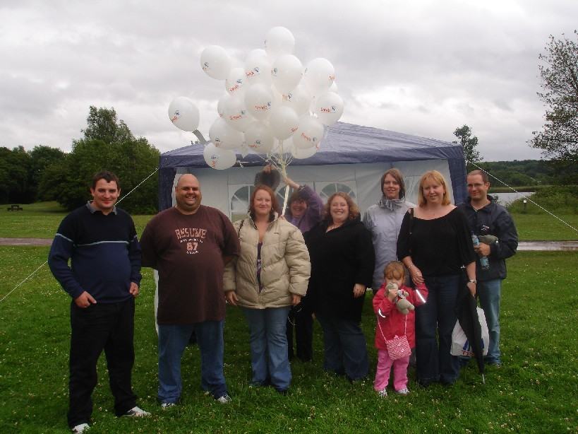

Bereavement Suite at UHW

The Bereavement Suite at UHW is now coming together with thanks to £1000 raised for us by Barry and Vale Rotary club. All the furniture has been bought and put together and is now in the suite, We are just waiting for some extra plug sockets to be put into the rooms and we’ve got a few pieces left to buy and then it will be ready and hopefully bring a little comfort to the parents that use the room

Lights of Love Service
14th December 2007
Every December National Sands holds a Lights of Love service in memory of babies who have died, these services are held in England, Scotland and Wales. This year the services will be held on Friday 14th December. Last year the Welsh service was held in Llandrindod Wells. Last year the service was lovely,with readings, poems and Christmas carols. During the service you are able to light a candle in memory of your baby and you can also write on a tag and place it on the Christmas tree. We are still awaiting final comfirmation of the location and time of this years service.We’ll keep you updated
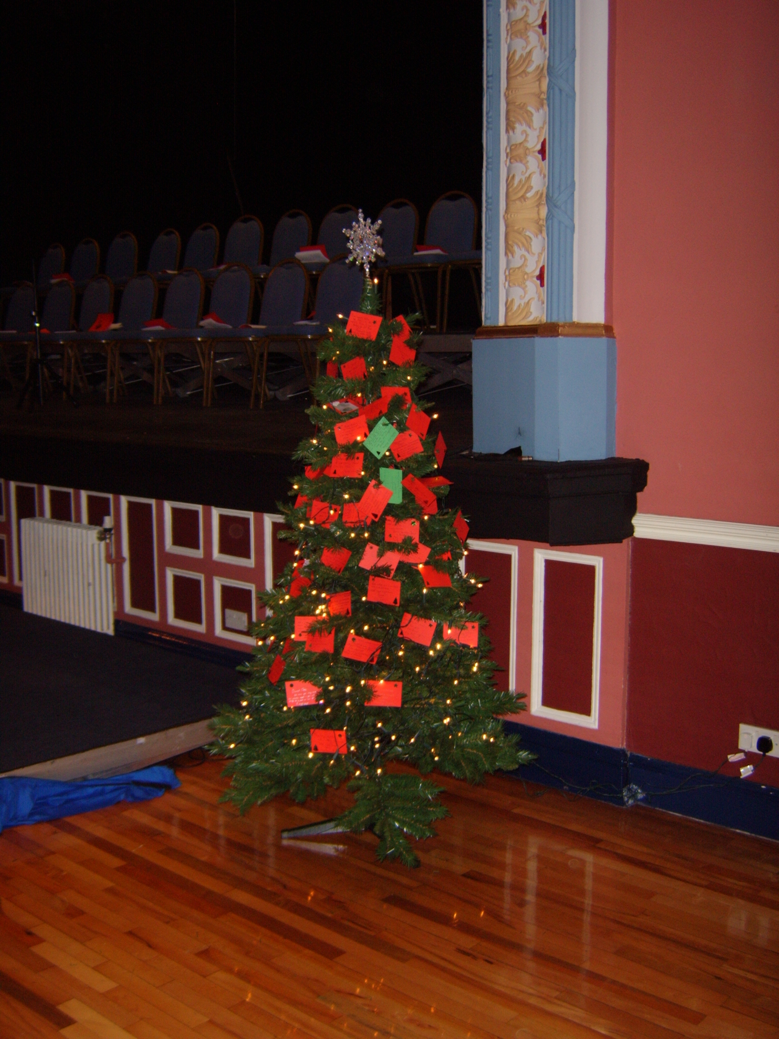

The silence
As you were born
the silence 'echoed' around the room
For our beautiful child
had been taken away to soon
You did not make a sound
Your eyes they did not open
We looked at you with love and pride
But inside our hearts were broken
Your tiny hands, and tiny feet
Your skin so soft to touch
You looked just like your daddy
and we love you oh so much
Your tiny heart had ceased to beat
Your lungs refused to scream
We hoped we would wake up soon
as surely this was a bad dream
And still,
The silence 'echoed' around the room
and reality began to take hold
You were never to come home with us
our world now seemed dark and cold
but you, our baby, you were born an angel
This cruel world you will not endure
and as we try to mend our broken hearts
remember we love you forever more
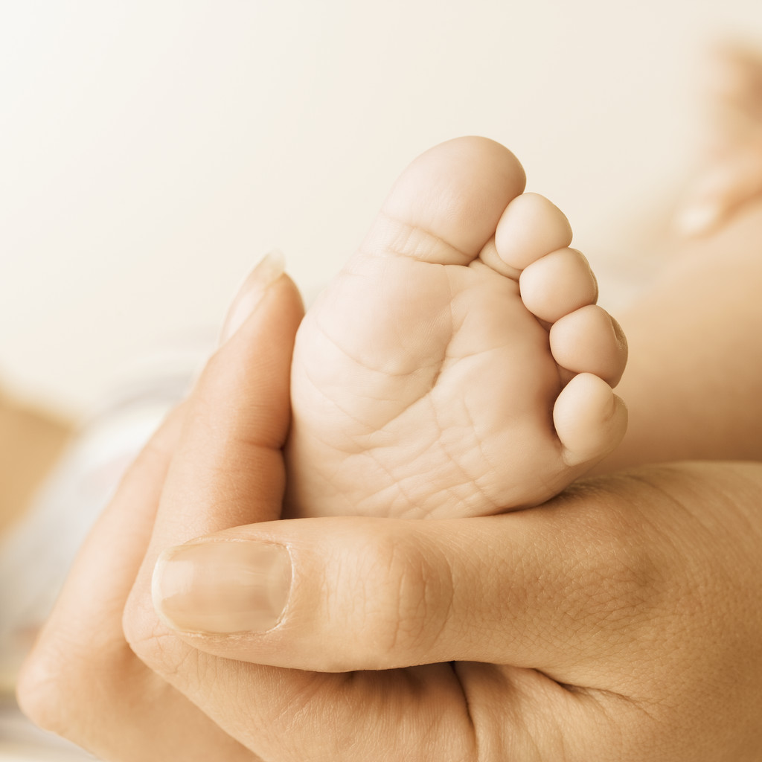

Fundraising for Cardiff Sands
Sarah Roberts, aunty of Seren, is running the Great North Run on 30th September in aid of Cardiff Sands. If you would like to sponsor her please contact either me (Claire) on cardiffsands_newsletter@hotmail.co.uk or Sarah on sarah.roberts@faulkes-telescope.com

Change of meeting times

If it is ok with everyone who attends the monthly support meetings the time is going to change to
7 – 9 pm .

New Befrienders for the group

William and Lisa have completed their befrienders training and now join Heather and Dave as the group befrienders. This means they can take befriender calls as well as taking the support meetings when Heather and Dave aren’t able to

We Remember
August – November

Xander Dangerfield Coombs 3rd Sep 2004

Bethan Victoria Cook 9th Oct 1997

Molly Frances Jones 18th Oct – 24th Oct 2006

Seren Roberts 5th Nov 2005

If you would like your baby’s birthday to be remembered in this section please e-mail their name and date of birth to cardiffsands_newsletter@hotmail.co.uk
Babyloss Awareness Week
9th – 15th October

We will not be holding any events for this but if you want to get involved or just want more information go to:

http://www.babyloss-awareness.org/index.htm

Contacting National Sands
SANDS NATIONAL HELPLINE: 020 7436 5881
The Helpline is open 9.30am - 5.30pm, Monday – Friday
The Helpline team are there to listen and give support. They can advise you about finding local help, whether from a SANDS group or other counselling services, and have information about other relevant support organisations.
SANDS HEAD OFFICE: 020 7436 7940
The Office is open 10am – 5pm, Monday - Friday
The office admin line is there for a broad range of enquiries relating to stillbirth and neonatal deaths.

WRITE TO:
28 Portland Place,
London,
W1B 1LY.

E-MAIL:
For the helpline support mail: helpline@uk-sands.org
For all general enquiries mail: support@uk-sands.org
For fundraising issues mail: fundraising@uk-sands.org

SEND A FAX:
020 7436 3715
WEB SITE:
http://www.uk-sands.org/

