
Issue 25 April 2015
www.cardiff-sands.co.uk

Welcome
We hope that this newsletter will provide you information on who we are, what we do and what we are up to. If you have any ideas, news, articles etc that you would like us to place in the newsletter please e-mail Claire at
cardiffsands_newsletter@hotmail.co.uk

The newsletter is issued every four months so the next issue will be in August, if you do have any news, articles, fundraising events, stories or poems that you would like to be added please e-mail the above address before July 16th. Previous issues of the newsletter can be found on www.cardiff-sands.co.uk
Who are we?
Cardiff & Newport Sands support group is for anyone who has been affected by the loss of a baby, be that late miscarriage, termination for an abnormality, stillbirth or neonatal loss.
We hold a monthly support meeting at St.David’s Hospital,
Cowbridge Road East, Canton, Cardiff, CF11 9XB. They are held on the last Thursday of every month, 7-9pm. Free parking is available.
The meetings are very informal, you can say as much or as little as you want. It is basically for people to share their experiences and feelings with others who have gone through similar and understand.
For more information go to www.cardiff-sands.co.uk

We also now run a next pregnancy support group, 7.15-915pm,on the last Thurs of the month at St.David’s Hospital, Canton, Cardiff

We have a befriender phone number in case anyone just needs someone to talk to. For the befriender number please call Sands on
020 74367940, or e-mail head office at support@uk-sands.org

Dates for your Diary

4th May
We have a few people running for us in the Cardiff Bay 5 mile run. There is a choice of the 5 mile run, or a 2k fun run. For more information go to http://www.cardiffbay5mile.org/

13th June
National Sands Memorial Garden Day, at the National Arboretum, Staffordshire. For more information go to https://www.uk-sands.org/support/remembering-your-baby/sands-annual-remembrance-service-and-garden-open-day

19th June
Our annual golf tournament and fundraising evening, at Pontypool Golf Club. Check our website www.cardiff-sands.co.uk for more details or email golf@cardiff-sands.co.uk

20th June
Sophia’s Market, see poster on next page

28th June
Our annual remembrance service organised by Cardiff Council Bereavement Services, will be held in the Wenallt Chapel at Thornhill Crematorium, at 11.30am. There will be refreshments afterwards

Rainbow Babies

Our Rainbow Babies group is on the 2nd Friday of every month, 10am-12noon at Cafe Junior, Fanny Street, Cardiff. This support and play group is especially for those who have gone on to have further children following loss. Free entry if you mention Sands. Our befriender Pip runs this group, if you have any questions to ask her about this group please email rainbowbabies@cardiff-sands.co.uk

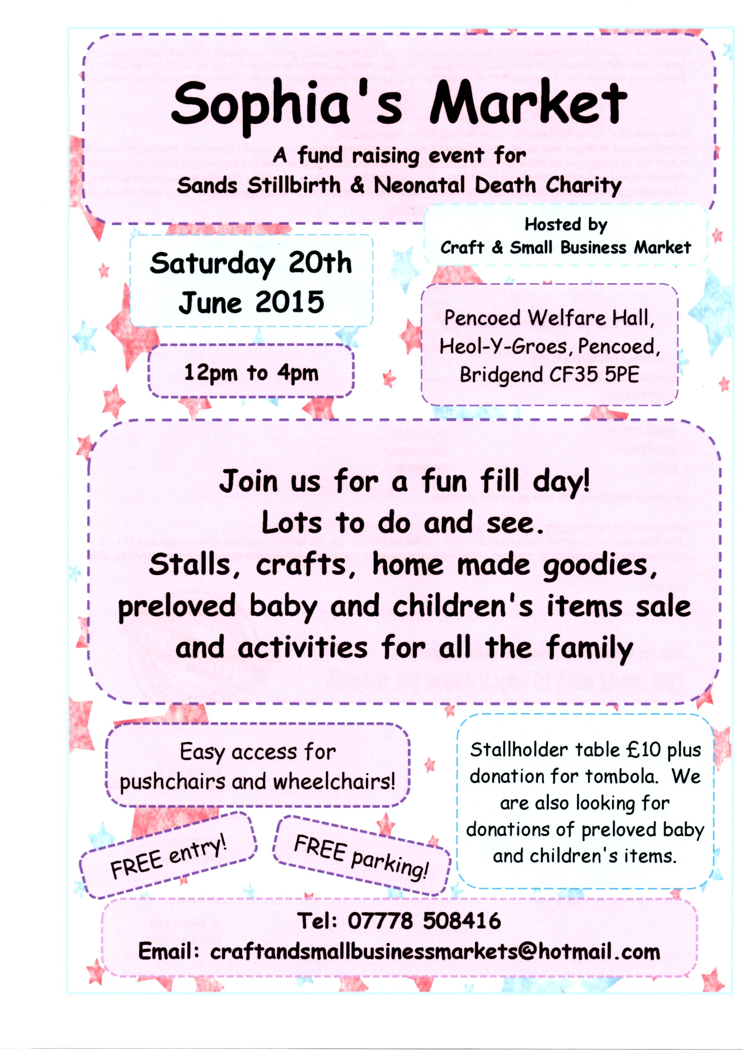
Xander Coombs Memorial Darts Tournament
In September 2014 our son Xander would have been 10yrs old. Dave and I decided we wanted to raise money and awareness in his name for his 10th year. Being great lovers of darts (Dave playing, me watching) we decided to look at the possibility of a darts tournament. Hayley and Chris attended January's support meeting and as Chris played darts for a rival darts team they offered to help find a venue.

The venue was Taffs Wells Ex Serviceman and Social Club who would let us use the room free of charge and speak to the BDO about borrowing some boards. Secretary of the Club - Lyn was amazing and helped so much in the preparation. Dave and I ordered some trophies for the winners and then in memory of Chris & Hayley's little girl Elsie as a thank you for helping with the venue, the Highest Check Out Trophy was in her name.

On the night we had 22 players, 12 men and 10 women. Mostly non players with no experience, which made for a fun and entertaining evening. The men's finals were made up of father and son Dave and Scott Powles and the ladies were Nicola Powles and Hayley Machin.

We had a break to draw the raffle just before the final and also to sing Happy Birthday to Dave and present him with a minion birthday cake. Thank you to everyone who bought and donated prizes.

The finals were played at the same time and the tension and anticipation filled the room. Son beat father and Hayley beat Nicola. We had our first winners of the Xander Coombs Memorial Darts Tournament. Scott Powles and Hayley Machin took home £66 in prize money and a trophy. Scott also won Elsie's Highest Check Out Trophy. Potential date for next year is April 8th 2016.
Heatherjane Coombs
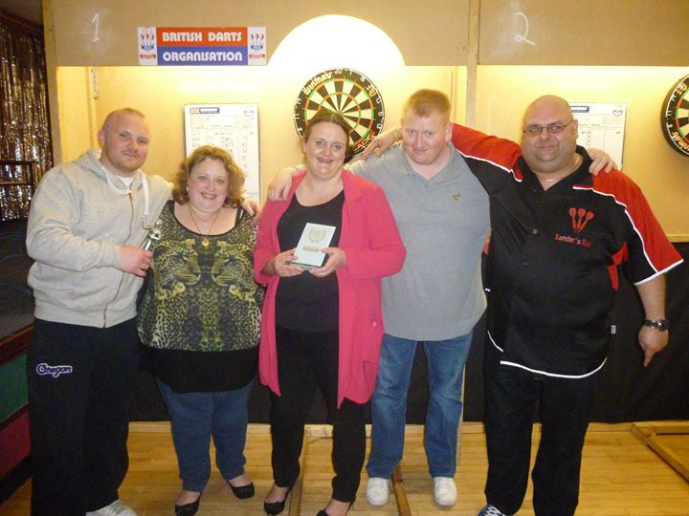
Royal Glamorgan Babies Remembrance Service,
St.Annes Church, 29th March

As Welsh Coordinator I was asked to attend a special babies remembrance service that had been organised by the Royal Glamorgan chaplaincy. I was asked to speak about the work of Sands and then read a story.

When we arrived we were given on opportunity to write down our babies name on a form which would be read out during the service and also to write your babies name on a small wooden heart which would then be placed on a memory tree.

The service was very well attended and was lovely to see some familiar faces, including the lovely midwife Karen Symonds and I got chance to have a cuddle with one of our new rainbow babies.

Was an honour to be invited and to do a reading in memory of all of our babies.

Heatherjane Coombs
Thank You
To everyone who raises money or donates to us, without you we cannot provide the support we do to parents, families and professionals
So thank you to the following people who have raised or donated money to:
Jennifer Smith, in memory of Daisy
Leekes Head Office
Llanbradach Line Dancing Club
Asda Pillgwenlly, Newport
Lauren Forward, who did a sky dive
Family and friends, in memory of Faith Griffith
Arnold Martin
Zoe Jenkins
Lauren Macgregor, in memory of Finley
And everyone else who has raised money for us, many thanks.
As examples of what we use the money for, in 2014 we have paid for midwives from three local hospitals to attend the Sands/Bliss Conference in London. We have also paid for two midwives (one part funded with Valley Sands) to attend the International Stillbirth Alliance Conference in Amsterdam. Cuddle cots for UHW and the Royal Gwent hospitals. As well as this we continue to supply four local hospitals with memory boxes, hand and ink kits, hand and footprint memory booklets and Sands support packs. We also pay for the printing of leaflets that are given out in the Cardiff & Vale UHB hospitals regarding pregnancy loss at any stage and what choices are regarding funerals etc (without our funding these leaflets would not be able to be provided as Cardiff & Vale UHB will not fund them)

Gift of remembrance Training

Back a few years ago Dave and I attended the Liverpool Sands AGM and we were present for an amazing presentation from Rachel Hayden of a charity named Gifts of Remembrance.

Her charity trained midwives/volunteers to take photographs of families to help them create a story of their time with their baby. We were both inspired by her but unfortunately the timing was wrong to bring her to Wales.

In September last year at the Sands/Bliss Conference, a number of our midwives asked if we would fund the training in Wales. With the help of Tanneke, bereavement midwife from the Princess of Wales hospital in Bridgend, who provided the venue, food and paid for Rachel's expenses we invited midwives from the Gwent, Glamorgan, Princess of Wales and UHW to attend the day. Also, as well as myself who attended as Welsh Network Co-Coordinator, 3 members of our group attended with the intention of helping out at the hospitals if parents would like these type of photographs.

During the training, we were put into groups of three and role played with dolls and equipment, from Rachel's guidance and training, the photos that were taken were really quite amazing, even from just ordinary digital cameras.

A photo book has been made using the photos from the day for each hospital so that other midwives who didn't attend can see the type of photos that can be taken.

Everyone left the course feeling inspired to help parents create better memories in the short time they have with their babies.
For more information and for a much better description, please have a look at Rachel's website and see the amazing work she does.

http://giftsofremembrance.co.uk/

Heatherjane Coombs

Welsh Sands Network Day,
hosted by Cardiff & Newport Sands

This year’s Welsh Network Day took place on Saturday 17th January at the University of South Wales, Atrium Campus, Cardiff City Centre. Unfortunately the weather (snow!) stopped some groups from attending so we only had 3 groups from 7 represented but we did have a great turnout from health professionals.

The morning kicked off with new Sands Trustee Margaret Evans who is a paediatric pathologist in Scotland giving us a talk entitled "Stillbirth, does pathology make a difference?" talking about how the placenta was the ‘black box’ of pregnancy. What an inspirational speaker, and Margaret was happy to answer many questions after her talk.

We had a great update from Karen Symonds from Cwm Taf UHB who Cardiff & Newport Sands partly funded (along with Valley Sands) to attend the International Stillbirth Alliance conference in Amsterdam alongside Yvonne Robinson, from Cardiff & Vale UHB, who we fully funded. They both got a lot out of the ISA which is great. It’s thanks to your donations that we can fund midwives to attend these kinds of study days/conferences so that they can share what they have learnt with their colleagues, and bring in best practises into the workplace with regards to bereavement

Update from the Sands Research team Laura ended the morning and Caroline Allsopp (our secretary) and Claire Roberts (our treasurer) presented Laura and Judith from Sands head office with a cheque for £10k to go towards helping to fund research.

After lunch we focused mainly on some workshops for the groups. It was a great day and a great chance to find out how some of the other groups and areas of Sands worked.

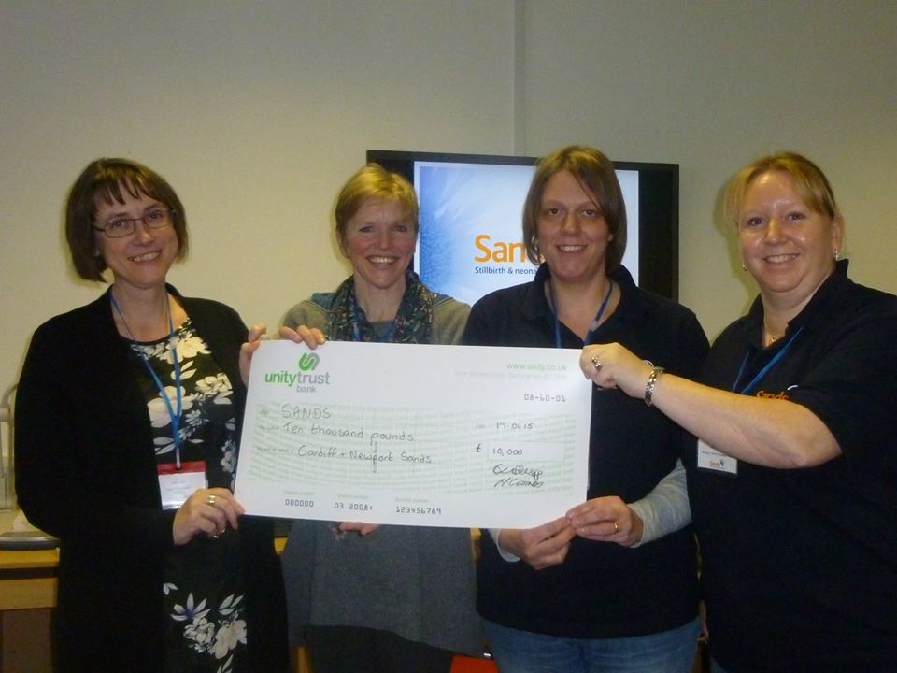
Heatherjane Coombs

2016 Calendar

This year we are going to do a calendar ready for 2016, which Asda Leckwith has kindly offered to sell for us. We have previously done a Hunks in Trunks calendar, and thought that this kind of calendar has been done too much now we so we needed another idea.

So.....our idea that we came up with was a photo competition. The photo needs to be something that reminds you of your baby. The only rules being we don’t want photos of your baby, or their grave. The more original idea the better and along with your photo can we just have a few lines to explain why you have taken your photo, and your babys name.

Entries need to be in to us by 11.59pm on the 31st May, and you can email them to (as a jpeg file please) :

calendar@cardiff-sands.co.uk

We will have a panel of judges (an Asda representative is one of them), who will whittle it down to the wining 12 entries.

So go and get clicking and Good Luck!

Any questions please email the above email address.

Tomorrow your mum will give you birth
Though you won't be staying here on earth
Lifted by an Angels wing
To a land where you can hear the bluebells ring
Where stars and rainbows last forever
Your memory we will always treasure.
By Erica Stewart

Written the night before my daughter gave birth to her stillborn son.

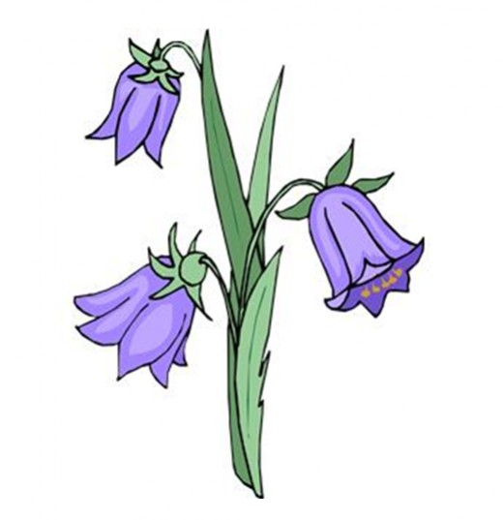

We Remember
April – July

April
4th April 2012 Evie Brown
15th April 2011 Evan Jenkins
16th April 2011 Una Grace Sweeney
18th April-19th April 2013 Jack Llewellyn Jenkins
21st April 2011 Erin Haf Bevan
24th April -27th April 2012 Aneurin Fred Owens
29th April 2013 Robert Brown

May
14th May -26th May 2010 Megan Jayne Harding
28th May 2006 Lewis Michael Watkins

June
1st June 2006 Billy Jon Lewis
4th June 2007 Samuel James Smitham 4th June -12th June 2007 Jack David Smitham 11th -13th June 2004 Alwyn Callaway 17th June 2005 Isobel Ker
21st June 2010 Anabelle Violet Morgan
27th June 2012 Harrison Raymond Metcalfe

July
3rd July 2011 T.J Thompson
11th July 2011 Mason Boyes-White
16th July 2013 Ollie George Loynton
15th July 2014 Emily May Loynton

If you would like your babies name adding to our We Remember section please email their full name and date of birth (and date of death if different) to cardiffsands_newsletter@hotmail.co.uk

Contacting National Sands
SANDS NATIONAL HELPLINE: 020 7436 5881

Mon-Fri 9.30am-5.30pm
Tues & Thurs eve 6pm-10pm
Closed weekends

The Helpline team are there to listen and give support. They can advise you about finding local help, whether from a SANDS group or other counselling services, and have information about other relevant support organisations.
SANDS HEAD OFFICE: 020 7436 7940
The Office is open 10am – 5pm, Monday - Friday
The office admin line is there for a broad range of enquiries relating to stillbirth and neonatal deaths.

WRITE TO:
28 Portland Place,
London,
W1B 1LY.

E-MAIL:
For the helpline support mail: helpline@uk-sands.org
For all general enquiries mail: support@uk-sands.org
For fundraising issues mail: fundraising@uk-sands.org

SEND A FAX:
020 7436 3715
WEB SITE:
http://www.uk-sands.org/

