
Issue 26 Aug 2015
www.cardiff-sands.co.uk

Welcome
We hope that this newsletter will provide you information on who we are, what we do and what we are up to. If you have any ideas, news, articles etc that you would like us to place in the newsletter please e-mail Claire at
cardiffsands_newsletter@hotmail.co.uk

The newsletter is issued every four months so the next issue will be in December, if you do have any news, articles, fundraising events, stories or poems that you would like to be added please e-mail the above address before November 16th. Previous issues of the newsletter can be found on www.cardiff-sands.co.uk
Who are we?
Cardiff & Newport Sands support group is for anyone who has been affected by the loss of a baby, be that late miscarriage, termination for an abnormality, stillbirth or neonatal loss.
We hold a monthly support meeting at St.David’s Hospital,
Cowbridge Road East, Canton, Cardiff, CF11 9XB. They are held on the last Thursday of every month, 7-9pm. Free parking is available.
The meetings are very informal, you can say as much or as little as you want. It is basically for people to share their experiences and feelings with others who have gone through similar and understand.
For more information go to www.cardiff-sands.co.uk

We also now run a next pregnancy support group, 7.15-915pm,on the last Thurs of the month at St.David’s Hospital, Canton, Cardiff

We have a befriender phone number in case anyone just needs someone to talk to. For the befriender number please call Sands on
020 74367940, or e-mail head office at support@uk-sands.org

Dates for your Diary

11th September
Adele Parks, top selling author of 15 books, all of which have been best sellers is coming to Cardiff to talk about herself and her books especially for us. The event is being held at the Park Inn, Cardiff City Centre (opposite CIA) 7pm (talk starts at 7.30pm) Tickets cost £15 and include free tea/coffee/canapés and a copy of one of her books which she will sign for you. To purchase a ticket go to www.cardiff-sands.co.uk/adeleparks

3rd October
National Sands are holding their AGM, this year at the Park Plaza Leeds, Boar Lane, City Square, Leeds LS1 5NS, at 9.30am.
https://www.uk-sands.org/about-us/membership/annual-general-meeting

11th October
For babyloss awareness week, this year we are holding a bubble release at Thornhill Crematorium 2pm. All Welcome

17th October
‘The Special Brew’ Live at Taff’s Well Ex Service Mans Club, 7.30pm. See poster later on in this newsletter for more info

4th December
Our annual Lights of Love Service will be held, once again at St.Saviours Church, Splott, Cardiff. More details will be sent out nearer the time
Rainbow Babies

Our Rainbow Babies group is on the 2nd Friday of every month, 10am-12noon at Cafe Junior, Fanny Street, Cardiff. This support and play group is especially for those who have gone on to have further children following loss. Free entry if you mention Sands. Our befriender Pip runs this group, if you have any questions to ask her about this group please email rainbowbabies@cardiff-sands.co.uk

The Seren Roberts Memorial Golf Tournament
Cardiff and Newport SANDS held the 5th Seren Roberts Memorial Golf Tournament and Fundraising Dinner at Pontypool Golf club on 19th June 2015, held in memory of organisers Gwyn and Claire Roberts' daughter Seren, who was still born in November 2005.

45 Golfers took part in this year's tournament, which was once again blessed with clear blue skies, providing the opportunity for some great golf to be played. It was a close competition this year, with the use of a live leader board keeping all golfers aware during their rounds about what they needed to do to take home to any prizes on offer.

In the Team Event, NHS Bandits eventually broke clear of the field, finishing 14 under par (12 under for the back nine), seeing off a tough challenge from Flower Power, and the West Cardiff Hitters
In the Individual Competition, Nicky Gardner stole the show, the only golfer to break par on a tough course, coming in at -5 playing
off 20. Nigel Morse's stunning drive of 350 yards plus won him the Longest Drive, whilst Eric Ursell's tee shot within 5ft on the 17th hole was enough to win the nearest the Pin.

The Evening fundraising event followed the presentation awards and dinner, where a quiz and auction entertained the crowd, whilst raising over £2,000 for Cardiff and Newport SANDS.

Once again, a huge thank you to everyone who came along and supported the event, and to all those who donated prizes to the golf competition, auction and raffle. Your support as always is very very appreciated.
Gwyn Roberts

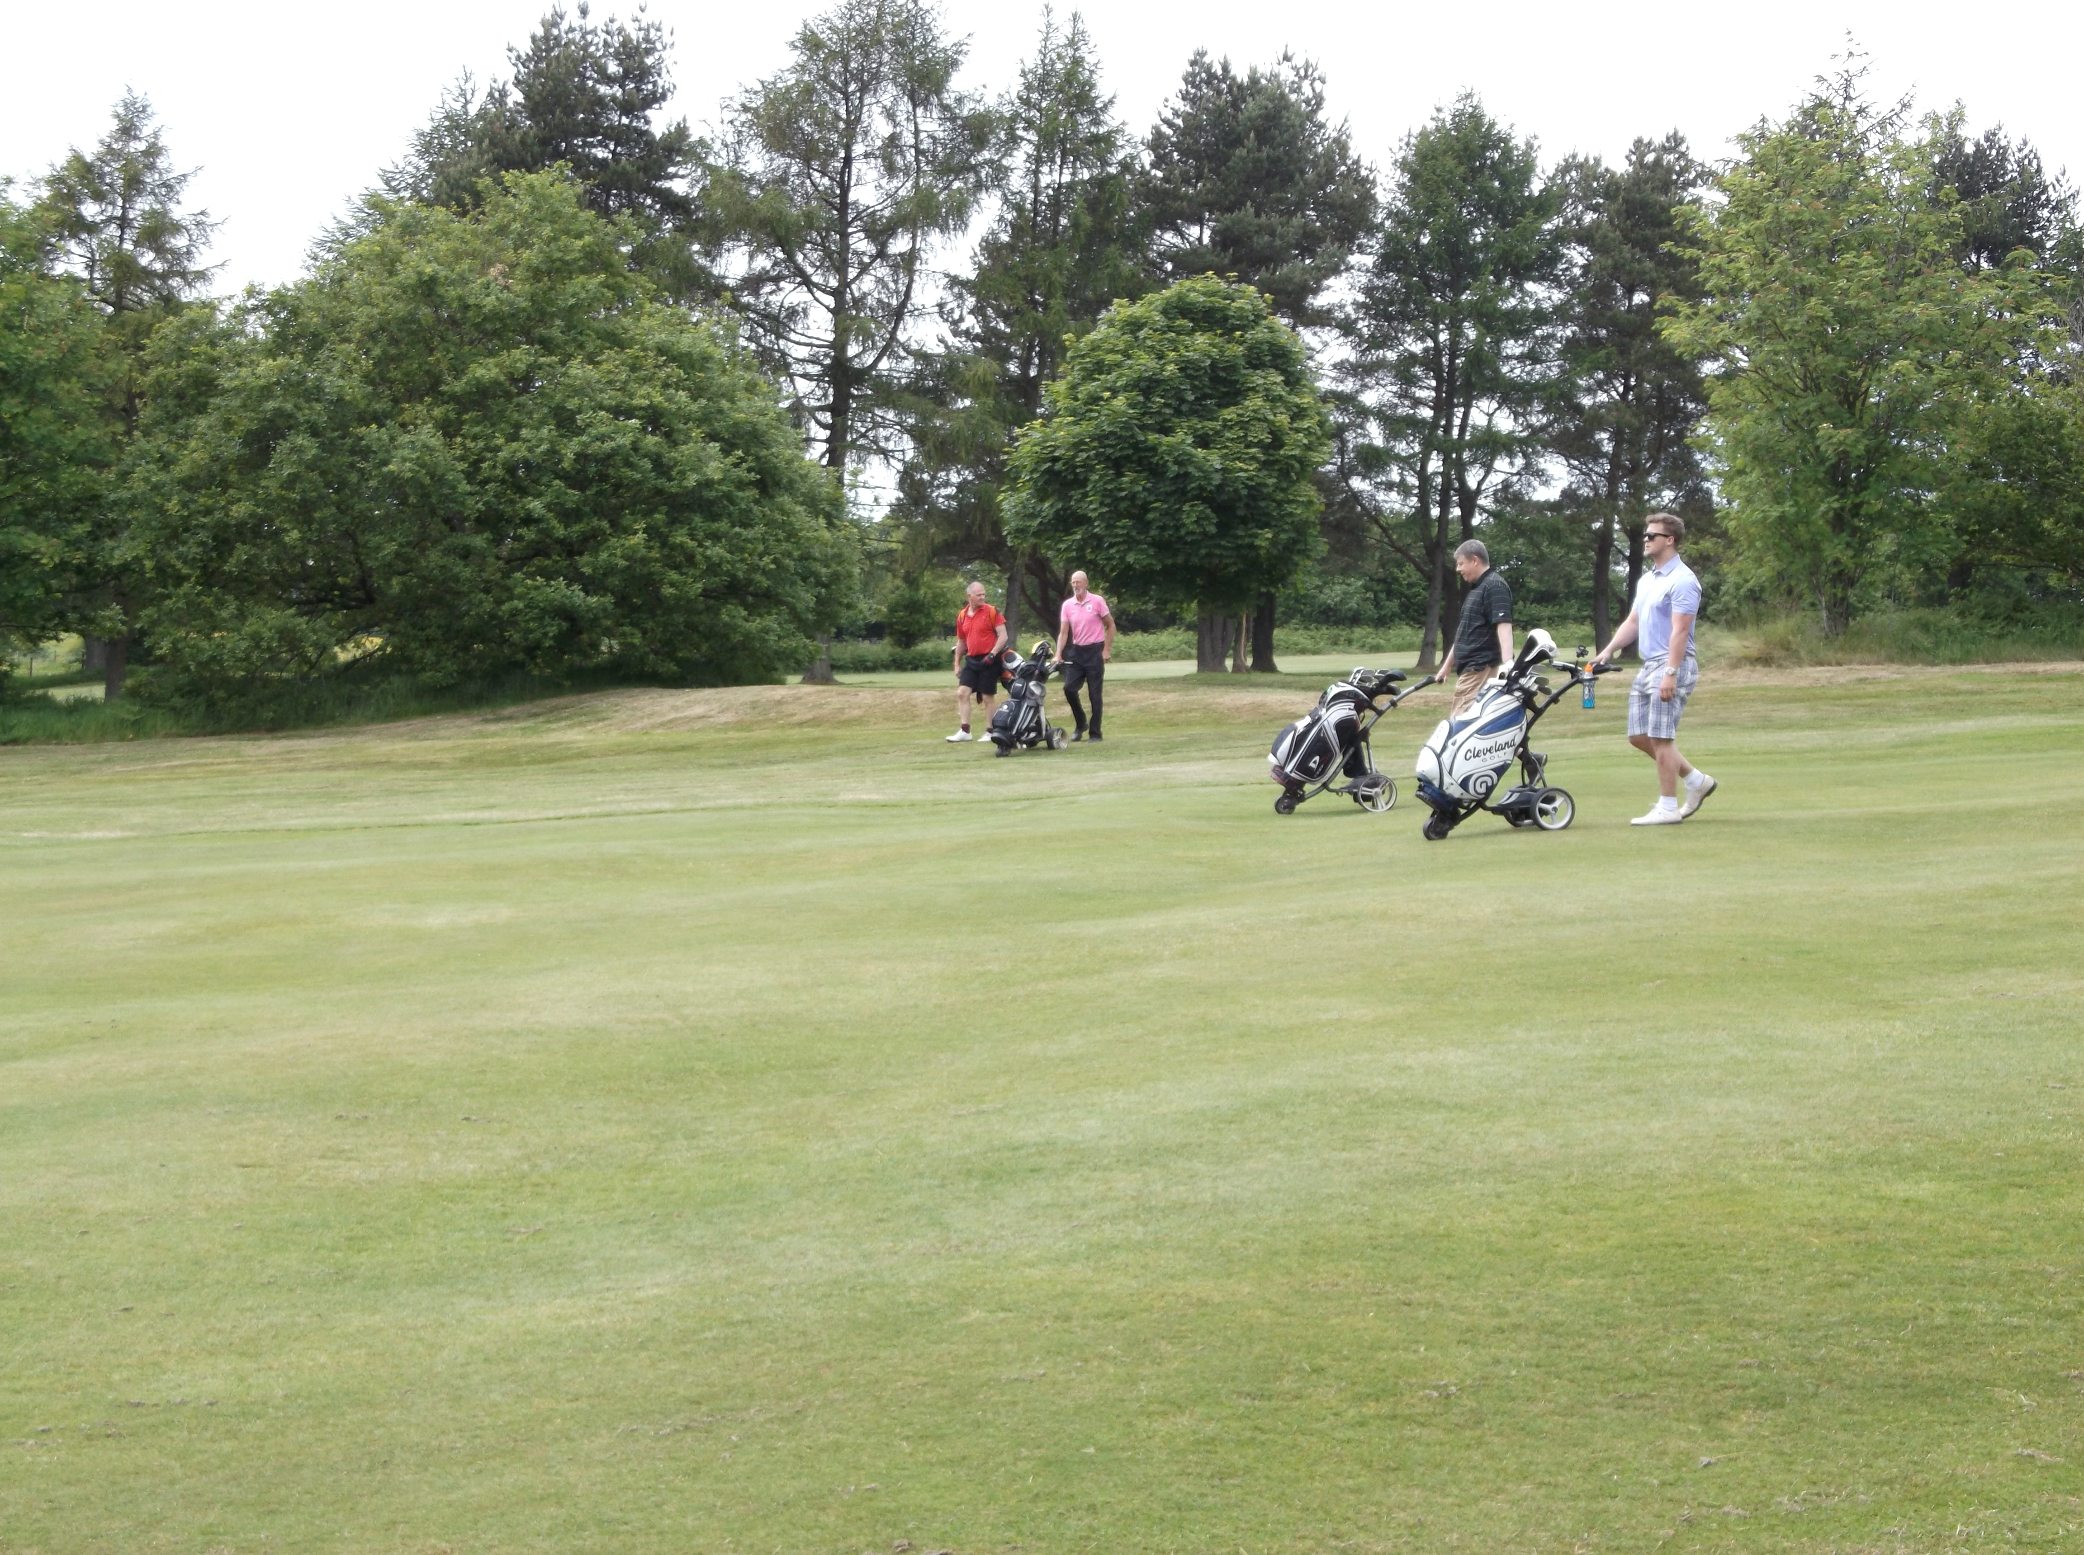
Student Midwives training and conference
‎On the 29th May 2015 the group helped pay for year 3 students to have a half day Sands Improving Bereavement Care training. The students receive a talk about the work of Sands which is then followed by a parent’s story. This year we were grateful to have the help of Jessica Sim who shared her story and her gorgeous little girl Megan with us all. Tissues were very much needed, but as usual the feedback from the midwives found the parents story invaluable. After our talk, workshops are run for practical studies and also a dvd is shown which has been made by bereaved parents.

We couldn't help the student midwives get this understanding without the support of our fundraisers and I know from the feedback they are very grateful for your help. Also, although not paid for by ourselves but another training day was also held in Cardiff on 1st June and huge thanks to Carolyn Ford for sharing her gorgeous daughter Carys with us.

When parents are brave enough to share their stories with health professionals it really helps them to get a better insight to our loss. So thank you to both Carolyn and Jessica.

As Welsh Network Co-ordinator I was also invited to talk as the All Wales Student Conference in May of this year. The group were invited to have a stand and also for a parent to share their story. The conference was really well organised and thanks to Sam Knight for helping with the stand and also to Carolyn Ford who as well as helping with the stand also told her story to the midwives, which from the feedback the students found inspirational.

Photograph is of myself and some of the other speakers.
Heatherjane Coombs
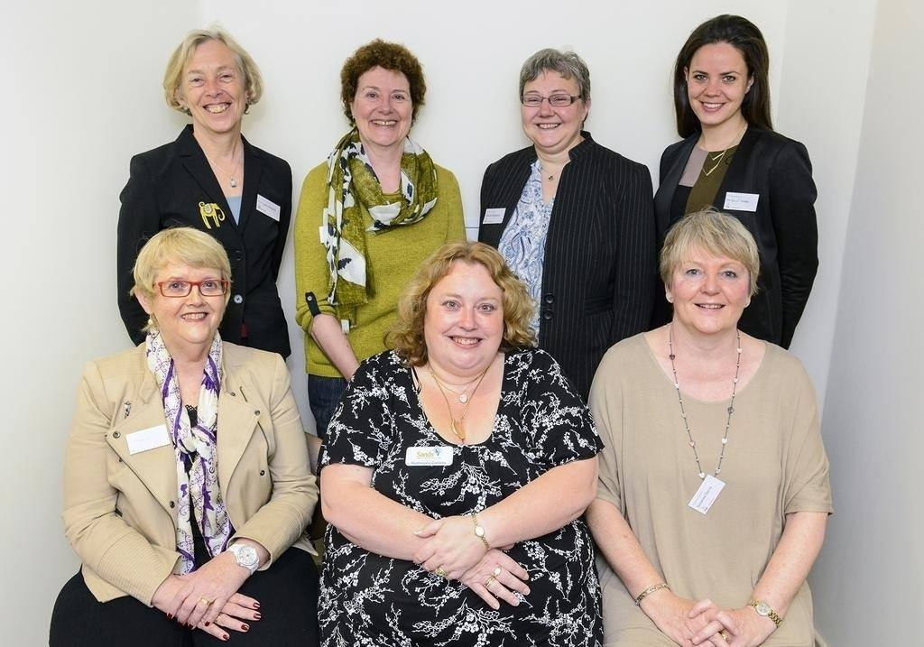
2016 Calendar
Recently we held a photo competition for a 2016 calendar we are doing. We had over 50 photo entries which was great, so a big thank you to each and every one of you who entered the competition.
The judging panel, which included the manager of Asda Leckwith who are going to sell the calendars for us, Kirsty who is kindly funding the printing, and Nicola, had a tough time deciding on the final 13 photos.
We will let you know once the calendars are ready for purchasing

Fundraising
I have been asked to mention a couple of fundraising events that bereaved families or friends of are organising/taking part in :
My colleague & friend are running the Cardiff half marathon on the 4th October for Sands with all proceeds going to Cardiff&Newport Sands. I didn't really know Jo before returning to work in September 2014, after my son Jacob was stillborn in October 2013, but we have been sat together ever since on the same team and she said she felt inspired to do something for the local sands group.
Her name is Joanne Ryan and her just giving page is as follows -
https://www.justgiving.com/Joanne-Ryan2
Thanks very much
Roz Luke

Tammy Nelder is collecting used postage stamps in aid of Sands, if you have any can you please contact her at tammylnelder@hotmail.co.uk to arrange getting them to her

Thornhill Remembrance Service
On Sunday 28th June, our annual remembrance service was held at Thornhill Crematorium which was organised by the bereavement services of Cardiff City Council along with Cardiff and Newport Sands. The service was well attended and beautifully arranged, everyone had the chance to write on a card and place it on the board of remembrance. Unfortunately the weather wasn't kind to us this year and it rained quite heavily as we all left to move to the ilex garden to place our stones, however, despite the rain it was still lovely. Had a chance to chat to a few people afterwards for coffee and hopefully everyone who attended found some comfort in the service.
Caroline Allsopp

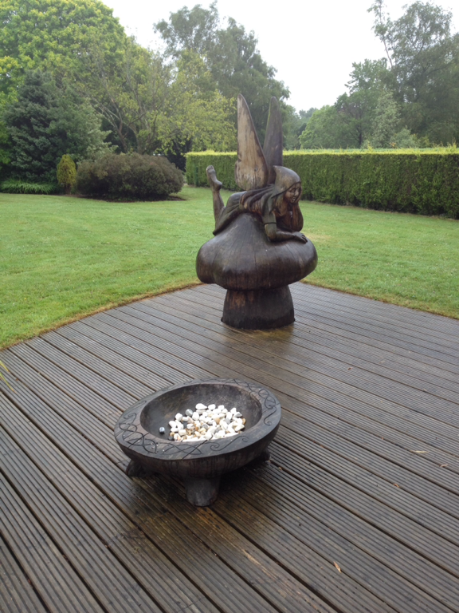

Thank You
To everyone who raises money or donates to us, without you we cannot provide the support we do to parents, families and professionals
So thank you to the following people who have raised or donated money to:

SE Furness, in memory of Aneurin
Asda
Family and friends, in memory of Ruben Ioan Logan Hill

And everyone else who has raised money for us, many thanks.
As examples of what we use the money for, in 2014 we have paid for midwives from three local hospitals to attend the Sands/Bliss Conference in London. We have also paid for two midwives (one part funded with Valley Sands) to attend the International Stillbirth Alliance Conference in Amsterdam. Cuddle cots for UHW and the Royal Gwent hospitals. As well as this we continue to supply four local hospitals with memory boxes, hand and ink kits, hand and footprint memory booklets and Sands support packs. We also pay for the printing of leaflets that are given out in the Cardiff & Vale UHB hospitals regarding pregnancy loss at any stage and what choices are regarding funerals etc (without our funding these leaflets would not be able to be provided as Cardiff & Vale UHB will not fund them)

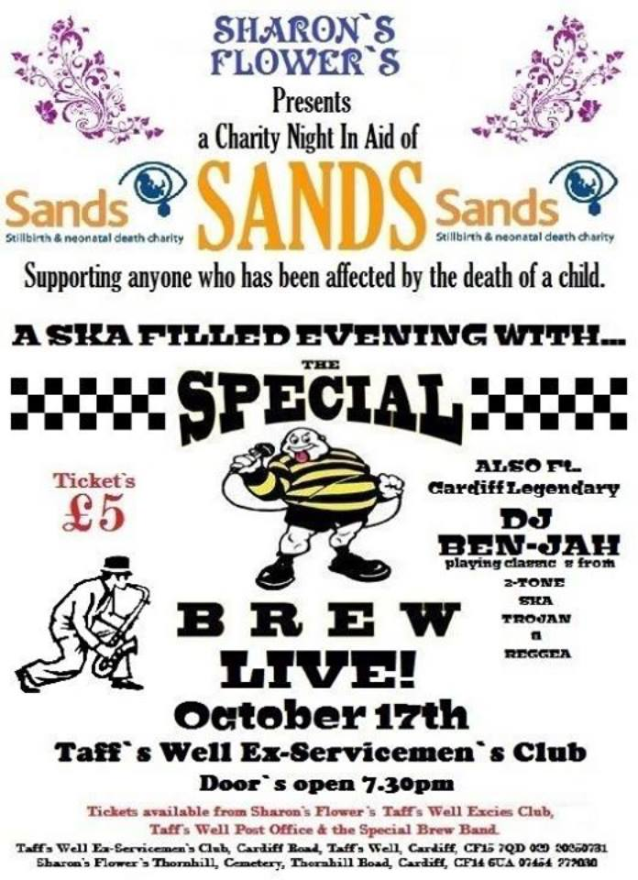

An evening with top selling author Adele Parks

11th September 2015
7pm
Park Inn, Cardiff City Centre
In aid of Cardiff & Newport Sands Charity

Come and meet Adele Parks, top selling author of books such as ‘The State We’re In’ and newly released ‘If You Go Away’. These are amongst her 15 books which have all been best sellers, she has sold over 3 million UK editions of her books

Have the unique chance to meet Adele, listen to her talk about her life, her writing, and her inspirations for her books. Get to ask her some questions, and receive a free book (included in the ticket price) for her to personally sign for you.

If you are a fan of Adele Parks then this must not be missed

Tickets are £15, and include free tea/coffee/canapés and an Adele Parks book for her to sign for you.

To book your tickets please go to
www.cardiff-sands.co.uk/adeleparks
or email fundraising@cardiff-sands.co.uk

A Father's Grief

It must be very difficult
To be a man in grief,
Since "men don't cry" and "men are strong,"
No tears can bring relief.
It must be very difficult
To stand up to the test,
And field the calls and visitors
So she can get some rest.
They always ask if she's alright
And what she's going through.
But seldom take his hand and ask,
"My friend, but how are you?"
He hears her crying in the night
And thinks his heart will break.
He dries her tears and comforts her,
But "stays strong" for her sake.
It must be very difficult
To start each day anew.
And try to be so very brave-
He lost his child too.

We Remember
August – November

August
5thAugust 2012 Finlay William Chapell
14th August 2009 Charley McFall
22nd August 2008 Seren Morgan Davies
22nd August 2011 Morgan Self
27th August 2010 Esme Rose Thomas-Faux
29th Aug – 30th Aug 2007 Ava Rose James

September
1st September 2011 Callum Gareth Morris
3rd September 2004 Xander Dangerfield Coombs
3rd September 2009 Freddie Cornelius
6th September 1995 Deborah Anne Ratcliffe
6th September 2003 Lucia Rose Kilshaw
17th September 2006 Grace Madison Bird
20th September 2006 Alex Christine Lambert
21st September 2006 William Sutherley
24th September 2013 Sienna Rose Evans
27th September 2006 Katy Jones
28th September 1998 Evan Lippiatt

October
9th October 1997 Bethan Victoria Cook1
10th October 2007 Iestyn Hewings
18th Oct – 24th Oct 2006 Molly Frances Jones
18thOctober 2003 Adam Lippiat
19th October 2009 Miley Jayne Ayre2
26th October 2002 Megan Smyth
28th Oct – 31st Oct 2011 Harry George Williams
31st October 2010 Cole Raymond Gallagher-Huntley

November
5th November 2005 Seren Roberts
8th November 2008 Lucy Annabelle Ingram
8th November 2008 Kai Patrick Lewis Crowley
8th November 2014 Elsie Grace Machin
22nd November 2013 Melody Eleanor Griffiths
27th November 2008 Lewys Christopher Bailey
28th November 2013 Ophelia Olwen Wright-Davies

If you would like your babies name adding to our We Remember section please email their full name and date of birth (and date of death if different) to cardiffsands_newsletter@hotmail.co.uk
Contacting National Sands
SANDS NATIONAL HELPLINE: 020 7436 5881

Mon-Fri 9.30am-5.30pm
Tues & Thurs eve 6pm-10pm
Closed weekends

The Helpline team are there to listen and give support. They can advise you about finding local help, whether from a SANDS group or other counselling services, and have information about other relevant support organisations.
SANDS HEAD OFFICE: 020 7436 7940
The Office is open 10am – 5pm, Monday - Friday
The office admin line is there for a broad range of enquiries relating to stillbirth and neonatal deaths.

WRITE TO:
28 Portland Place,
London,
W1B 1LY.

E-MAIL:
For the helpline support mail: helpline@uk-sands.org
For all general enquiries mail: support@uk-sands.org
For fundraising issues mail: fundraising@uk-sands.org

SEND A FAX:
020 7436 3715
WEB SITE:
http://www.uk-sands.org/

